SPRING AU 2022
DATABASE ASSIGNMENT

Name – K S Saivaibhav
Employee Code – INT1290

Problem Statement
The first assignment for you is to design a schema for a library management system. The library management system manages books and users and allows users to borrow books from the library and track the returns. Please design the schema to ensure that the following queries can be done

1. List of all books issued by a user
2. List all books overdue
3. List all books overdue by a user

Entities and Attributes
- User – UserID , FirstName, LastName, PhoneNumber, Email
- Book – BookID , Title , Author , Publication
- Ledger – LedgerNumber ,UserID, BookID , IssuedDate , ReturnDate

Database Schema

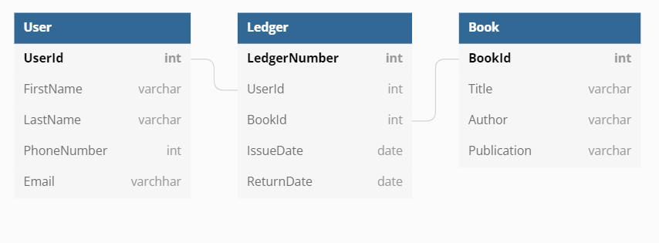
Creating Tables

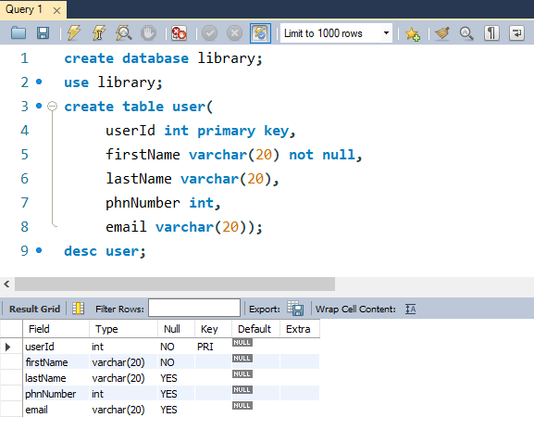
User Table

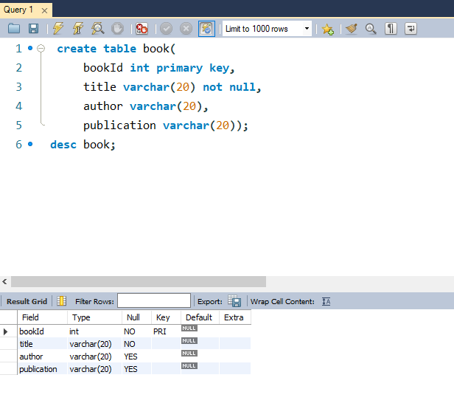
Book Table
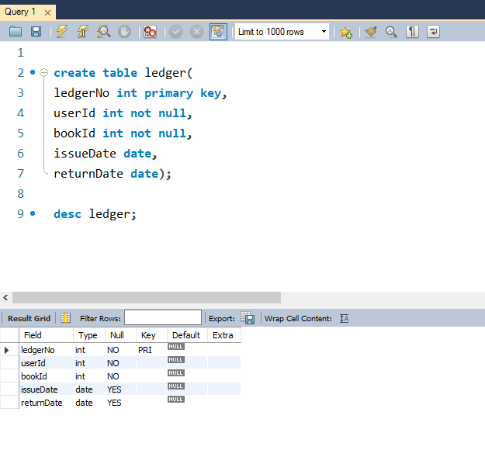
Ledger Table

Inserting Data values into Tables and Displaying

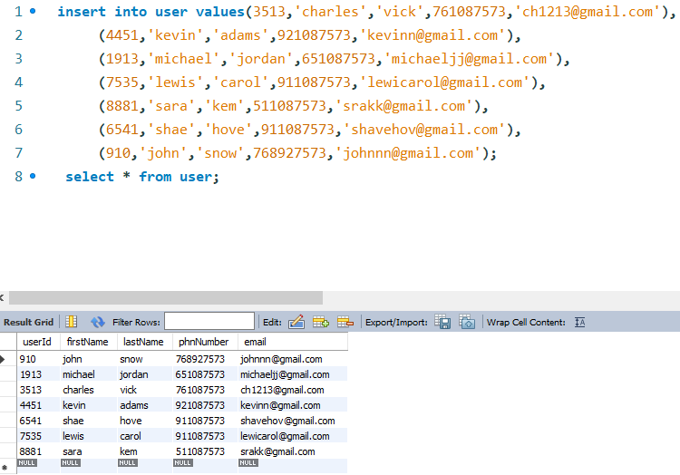

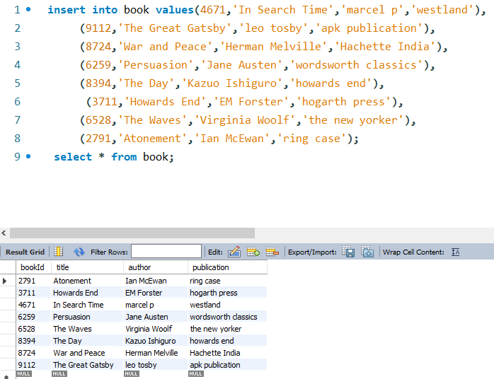

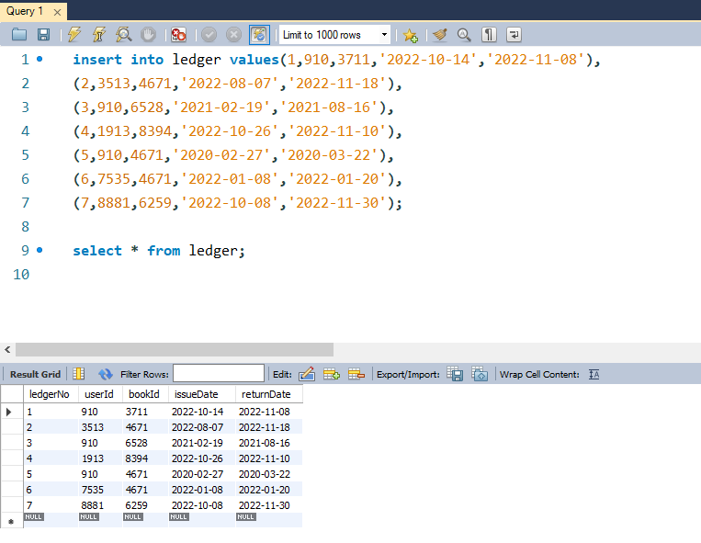
Queries

- List all books issued by a user.
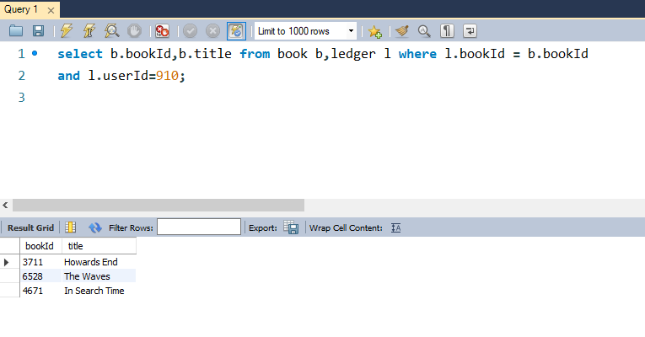

- List all book overdue

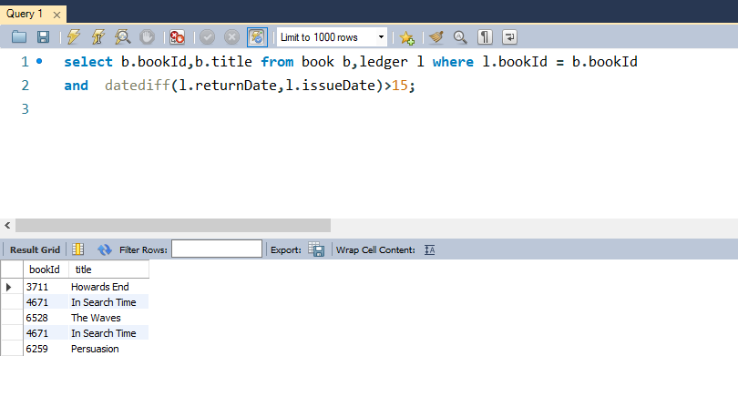

Note: 15 Days is considered as overdue period.

- List all books overdue by a user

